Carbon Reduction Plan

Supplier name: Ntrinsic Consulting Europe
Publication date: 30th November 2023

Commitment to achieving Net Zero
Ntrinsic Consulting Europe is committed to achieving Net Zero emissions by 2045.

Baseline Emissions Footprint
Baseline emissions are a record of the greenhouse gases that have been produced in the past and were produced prior to the introduction of any strategies to reduce emissions. Baseline emissions are the reference point against which emissions reduction can be measured.

Baseline Year: January - December 2019.
Additional Details relating to the Baseline Emissions calculations.
We conducted our initial carbon assessment in H1 2022 and used 2019 as the most realistic baseline year as the following years were impacted by Covid19 and remote working.
Our baseline year of 2019 (along with 2020 & 2021) was also updated to include emissions associated with newly acquired company Neusta.
Baseline year emissions:
Scope 1 | 84.27 tCO2e  Scope 1: Natural Gas, Petrol, Diesel from leased vehicles
Scope 2 | 158.82  Scope 2: Electricity and District Heating
Scope 3  (Included Sources) | 142.21 tCO2e  Scope 3:  - Waste  - Business Travel  - Water
Total Emissions | 385 tCO2e

Current Emissions Reporting

Further change to boundary for 2022 data: In 2022 the scope of the footprint was altered to include further Scope 3 Categories: Purchased Goods & Services, Upstream transport & Distribution and Employee Commuting. In addition we increased our boundary to include an additional 3 sites across Scope 1, 2 and 3.

Reporting Year: January - December 2022
Scope 1 | 100.15 (tCO2e)  Scope 1: Natural Gas, Petrol, Diesel from leased vehicles  Increase is due to change in boundary with an additional 3 sites now included.
Scope 2 | 162.27 (tCO2e)  Scope 2: Electricity and District Heating  Increase is due to change in boundary with an additional 3 sites now included.
Scope 3  (Included Sources) | 5,776.33 tCO2e  Included Scope 3 categories:  - Purchased Goods and Services *  - Upstream Transport & Distribution  - Waste  - Business Travel  - Employee Commuting  *Transportation & Distribution associated with PG&S and Capital Goods are included in the emission figures.  Increase due to the scope of the footprint increasing to include further Scope 3 Categories: Purchased Goods & Services, Upstream transport & Distribution and Employee Commuting and an additional 3 sites.
Total Emissions | 6,039 (tCO2e)

Emissions reduction targets
Please see excerpt from our Sustainability Strategy and Report 2022 pg. 46.

We have committed to achieving total Net Zero emissions (including scope 3) by 2045, 5 years ahead of the 2050 deadline called for in the Paris Agreement (Paris Agreement to the United Nations Framework Convention on Climate Change) through the following carbon reduction plan;
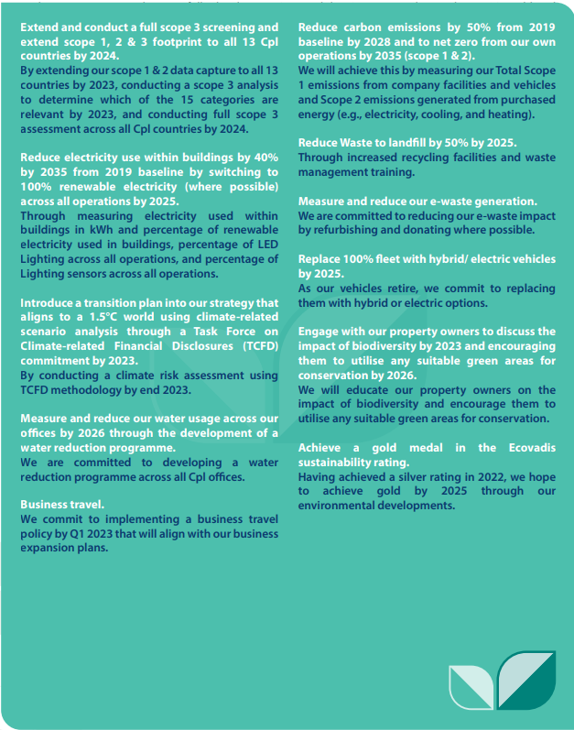

Carbon Reduction Projects
Please see our Sustainability Strategy and Report to further details on our Carbon Reduction Projects.

Declaration and Sign Off
This Carbon Reduction Plan has been completed in accordance with PPN 06/21 and associated guidance and reporting standard for Carbon Reduction Plans.
Emissions have been reported and recorded in accordance with the published reporting standard for Carbon Reduction Plans and the GHG Reporting Protocol corporate standard and uses the appropriate Government emission conversion factors for greenhouse gas company reporting.
Scope 1 and Scope 2 emissions have been reported in accordance with SECR requirements, and the required subset of Scope 3 emissions have been reported in accordance with the published reporting standard for Carbon Reduction Plans and the Corporate Value Chain (Scope 3) Standard.
This Carbon Reduction Plan has been reviewed and signed off by the board of directors (or equivalent management body).

Signed on behalf of the Supplier:
Sharon Vize
Group HR Director and Executive Sustainability Sponsor
………………………………………………………………….
Date: 13th November 2023

https://ghgprotocol.org/corporate-standard
https://www.gov.uk/government/collections/government-conversion-factors-for-company-reporting
https://ghgprotocol.org/standards/scope-3-standard

